Name: Class:

Task 1
Match each sensor to the sensor name. Then match each sensor to its uses.
Sensor |  | Sensor name |  | Uses
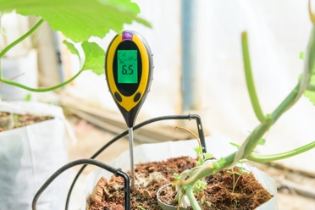 |  | Gas sensor |  | - Finding how much fuel is left in a car  - Finding the amount of grain stored in a silo
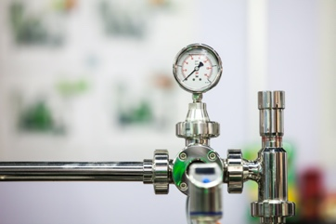 |  | pH sensor |  | - Detecting if someone is standing on a special mat at an entrance  - Detecting how much air is in a car tyre
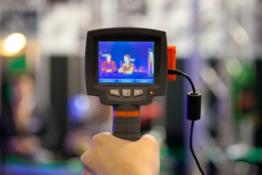 |  | Light sensor |  | - Detecting CO₂ levels  - Detecting O₂ levels  - Detecting CO (carbon monoxide) levels in a home alarm
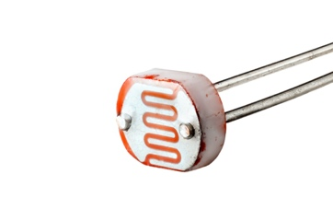 |  | Level sensor |  | - Detecting the acidity of soil  - Detecting the acidity of liquids
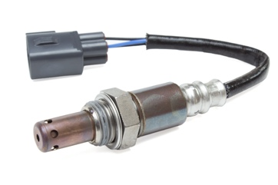 |  | Pressure sensor |  | - Automatic turning on of car lights  - Turning on street lights
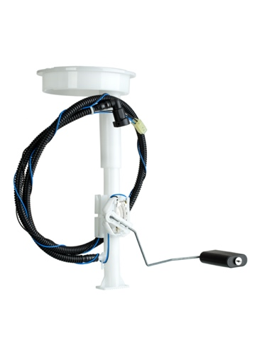 |  | Infra-red sensor |  | - Security lights  - Detecting movement in alarm systems  - Detecting areas in walls that are not well insulated

Task 2
The following sensors are covered in this topic:
- Acoustic  - Accelerometer  - Flow  - Gas  - Humidity  - Infra-red  - Level  - Light | - Magnetic field  - Moisture  - pH  - Pressure  - Proximity  - Temperature
Work with a partner to consider the most effective way to make a security alarm system for your school or home.
(a) Draw a diagram to show where different sensors are placed.

(b) Discuss which sensors are likely to work best at detecting intruders but are least likely to have false alarms. Make notes based on your discussion below.

Task 3
A company makes fish tanks. Their new design has the following requirements:
- Maintain a temperature between 24ºC and 26ºC. This can be maintained using a heater and a blind that is operated by a motor.
- Show the pH level which should be between 6.8 and 7.6. An LCD display and buzzer is available for notifying the user if the pH falls outside these pH levels.
- If it is daytime, the tank will turn on an air stone which will increase the amount of oxygen in the water.

(a) State the three sensors required for the fish tank.
Sensor 1:
Sensor 2:
Sensor 3:

(b) Discuss how the sensors will work together as part of a digital control system.

